Name: ____________________________ Period: _______

Student Background Information
DNA ⇒ RNA ⇒ PROTEIN is the central dogma of molecular biology. The DNA stores the information; following the DNA instructions three different types of RNAs (messenger, transfer and ribosomal) assemble the proteins, which do much of the actual work. Proteins play a key role in almost everything that organisms do, and carry out most of the work in the cell.
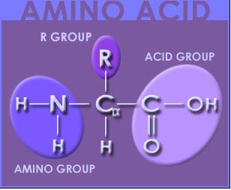
Amino acids are the building blocks of proteins. There are 20 types of amino acids coded for in the Universal Genetic Code. The Universal Genetic Code shows the sequence of nucleotides, coded in triplets (codons), along the mRNA, that determines the sequence of amino acids during protein synthesis. The DNA sequence of a gene can be used to predict the mRNA sequence, and the Universal Genetic Code can in turn be used to predict the corresponding amino acid sequence. Your Biology Textbook should have a diagram of the Universal Genetic Code.
Figure 1. General structure of amino acids
All amino acids share a basic structure: a central carbon atom (α)with a carboxyl (acid) group, a hydrogen atom, an amino group and a variable side chain (R). The nature of the ‘R’ chain determines the amino acid. Your biology textbook should provide a reference for the structure of all the amino acids. See Figure 1 (from http://www.stanford.edu).
Amino acids are held together by peptide bonds. Peptide bonds form when the amino group of one amino acid chemically binds to the carboxyl group of an adjacent amino acid. During this process a molecule of water is lost. This type of chemical bonding is also referred to as ‘dehydration synthesis’.
Long chains of amino acids are called polypeptides. A protein is one or more polypeptides folded into a particular 3-D shape, or conformation. For most proteins there is a single 3-D shape that is most stable and at which the protein works best.
There are four different levels of protein structure. Each level plays a crucial role in the final 3-D configuration of the protein. The first, or primary structure is determined by the sequence of amino acids.
The amino acids in the chain interact with each other: there are intramolecular and intermolecular hydrogen bonds formed among the amino groups; these give the chain a very specific geometric shape called the secondary structure.
Figure 2. Different levels of protein structure
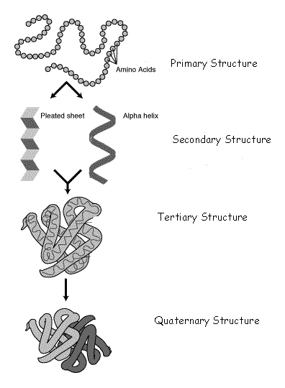
Tertiary structure is
determined by the interactions
between the "side chains" of the
amino acids. These interactions
are caused by a variety of bonds
that cause a number of folds,
bends, and loops in the protein
chain.

The quaternary protein
structure occurs when different
chains of polypeptides in the
protein interact with one another
and fold the already folded
structure into an specific shape
(see Figure 2).

Scientists have not yet learned
how to accurately predict the
3-D structure of a particular
sequence of amino acids.
However, we do know that
The different amino acids have
Distinct chemical properties determined by their variable side
chains. It is important to
remember that the amino acids
are 3-D structures themselves.

Although the structural formulas
for amino acids are 2-D on paper,
all molecules have a 3-D shape
that is determined by chemical
bonds. One of the most important
properties of the side chain is
whether it is polar (hydrophilic) or
non-polar (hydrophobic).
http://www.contexo.info/DNA_Basics/images/proteinstructuresweb.gif

One of the key determinants of protein shape is the hydrophobic interaction. Proteins fold in a way that maximizes having polar amino acids on the outside and non-polar on the inside. The shape of the protein gives it chemical properties that allow the protein to perform specific functions in the cell. Mutating the sequence (changing even one amino acid) may disrupt this 3-D structure and may, therefore, affect the function.

In this lab we will focus on the relationship between a protein enzyme and its substrate.
Substrate Products
enzyme

Enzymes are active proteins that catalyze chemical reactions. Catalysts are molecules or substances that make chemical reactions go faster. Many of the chemical reactions in your body wouldn’t happen at all, or would occur too slowly, without the presence of a catalyst. In the course of the chemical reaction the catalyst is not changed –thus enzymes can be used by your body over and over and over. Substrates are what the enzymes work on, and are chemically changed into a product by the reaction. The specific point in the enzyme where the substrate binds is called the active site. See Figure 3 below. Notice that the enzyme is not changed in the course of the reaction.
Figure 3. Lock and key model of enzyme action
Active site
Adapted from: http://stezlab1.unl.edu/reu1999/dputn226/ChemHelp/RET_Web_Pages/Enzymes/lock_key1.gif

One model used to explain enzyme action and activity is the “lock and key” model. Locks and keys have complementary shapes that allow them to fit and to work together. A slight change in the groves of the key and it won’t fit in the lock, or it will fit but it still won’t be able to open the door. Similarly enzymes and their substrates have complementary shapes. According to this model, the substrate fits in the active site of the enzyme and for a brief moment together they form the ‘enzyme-substrate complex’. The better the fit between the substrate and the active site of the enzyme, the faster the reaction will happen. When the reaction is completed the products are released from the active site and the enzyme can be used to catalyze the same chemical reaction if there is more substrate. This model also illustrates enzyme specificity: enzymes are specific to a particular reaction and can only catalyze one or very few chemical reactions.
Many different factors affect the work of enzymes. Temperature and pH are two such factors. All enzymes work best at a narrow temperature and pH range. Although a small increase in temperature can serve as a catalyst to some chemical reactions, a sharp increase in temperature will affect the chemical bonds within the enzyme and can irreversibly distort the active site. A malformed active site will prevent the substrate from binding to the enzyme and preclude the reaction from taking place. When enzymes are rendered useless they are said to have been ‘denatured’. Likewise, all enzymes will work best at a particular pH. A drastic increase or decrease in the pH surrounding the enzyme and denaturing can occur.
References
BBC:
http://www.bbc.co.uk/education/asguru/biology/02biologicalmolecules/01proteins/12polymers/06 polymers_b/index.shtml

Bio Topics
http://www.biotopics.co.uk

Chemistry of Life’s Toolbox
http://stezlab1.unl.edu/reu1999/dputn226/ChemHelp/RET_Web_Pages/Enzymes/lock_key1.gif

The Community College of Baltimore County Student
http://student.ccbcmd.edu/~gkaiser/biotutorials/proteins/images/peptidebond.jpg

Context.info
http://www.contexo.info/DNA_Basics/images/proteinstructuresweb.gif

Elmhurst College
http://www.elmhurst.edu/~c hm/vchembook/566secprotein.html

Mange and Mange. 1999. Basic Human Genetics. Sinauer Associates, Inc. Pg. 361.

North Harris College
http://science.nhmccd.edu/biol/dehydrat/dehydrat.html

Stanford University HOPES – Huntington’s Outreach Project for Education at Stanford:
http://www.stanford.edu/group/hopes/basics/proteins/p3.html

Utah Genetics:
http://learn.genetics.utah.edu/units/disorders/mutations/mutatedna.cfm

The Building Blocks of Life:  Examining the Importance of Enzyme Shape | 
Name: ___________________________ Date: _________
Introduction
Proteins do much of the work in the cell. The shapes of proteins are critical in determining their function. Proteins consist of a linear chain of amino acids and fold into a specific 3-D shape, or conformation. The pattern of folding is largely determined by whether the amino acids are hydrophobic (water hating) or hydrophilic (water loving). In this lab we will focus on the interaction between a protein enzyme (molecules that catalyze chemical reactions) and its substrate (the molecules that the enzymes act upon). You will often hear of the “lock and key” model to describe the way in which enzymes and substrates interact. The active site of an enzyme often has a shape that is complementary to the substrate.
DNA is the genetic material. The sequence of DNA will ultimately determine the sequence of amino acids in a protein. First the information in the DNA must be copied into a messenger RNA molecule. The RNA is complementary to the DNA molecule such that G always pairs with C and T with A. However, RNA contains U instead of T, so where there is an A(adenine) in the DNA, the RNA will have a U (uracil). The Universal Genetic Code is the key used to decode the relationship between the sequence of bases in the messenger RNA and the sequence of amino acids.
In this lab you will build a model of an enzyme using Lego® pieces and you will then examine how a mutation (a change in the amino acid sequence) can lead to a change in the shape, and thereby the function, of the enzyme.

PART I: THE NORMAL ENZYME
Procedure
- Obtain a Lego® kit from your teacher. This contains an assembled structure (the substrate) and Lego® building blocks which represent amino acids that will be used to assemble the enzyme.
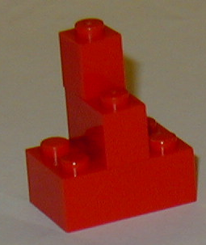
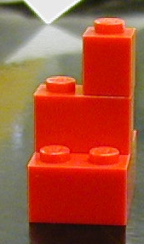
- Observe the substrate and predict the shape of an enzyme that could interact (fit) with the substrate. Then use all, or at least most of the Legos ® to create an enzyme that would interact with your substrate. Fit the enzyme and the substrate together to create the enzyme-substrate complex. Use the box at right to sketch the enzyme as it interacts with the substrate. Color the substrate only, and label both substrate and enzyme. Keep this structure. Do not take it apart until you are directed to do so.

- Using the DNA sequence of the normal enzyme given below and the information on TABLE 1, determine the primary structure (amino acid sequence) of the enzyme. Transcribe the sequence and record the amino acid and Lego® sequence on your Worksheet Page for future reference.
DNA Sequence of Normal Enzyme:
3’CGATAATCATAACAAGATACCGTGTAACTA5’

- Get a second set of Lego® pieces. Using TABLE 2: “The Blueprint”, assemble the 3D structure of the normal enzyme. Draw it in the box; colors are not necessary.

- How does it compare to the enzyme you had created in step 2? List two similarities and two differences in the structure (not the colors).
________________________________________________________________________________________________________________________________________________________________________________________________________________________________________________

- How does the normal enzyme bind to the substrate? Try to fit the substrate into the enzyme but do not snap together (the enzyme might become undone easily when trying to pull the substrate away and can be quite frustrating). Set the predicted enzyme, the normal enzyme and the substrate aside. To help you keep track of these three structures, take a blank piece of paper and write, at three different points on the paper: ‘Predicted Enzyme’, ‘Normal Enzyme’ and ‘Substrate.’ Place the corresponding structures on the paper accordingly.

PART II: MUTANT ENZYMES
Procedure
- Observe the DNA sequence for the 4 mutant DNA sequences on the Worksheet Page.
- Using the DNA sequences and TABLE 1, determine the primary structure (amino acid sequence) of each of the mutant enzymes. Transcribe these sequences and record the amino acid and Lego® sequence on your Worksheet Page. Circle or highlight the location of the amino acid substitutions in each mutant enzyme.
- In genetics, a normal sequence (or individual) is called a ‘wild-type’ and any sequences (or individuals) exhibiting changes are called mutants. Compare the primary structure of each mutant to the normal “wild-type” amino acid sequence. Predict which mutants will still be able to bind to the substrate and which mutants will not be able to bind to the substrate. Record your predictions on the Prediction Chart below.
- Using TABLE 2 (the Blueprint), and the amino acid sequence on the Worksheet Page, assemble the 3-D structure of mutant enzyme #1. Determine whether or not the enzyme can bind to the substrate, as the normal enzyme does. Use the building blocks that you used to build the predicted enzyme (the first enzyme that you built). Don’t forget to substitute the amino acid according to the mutation.
***To construct your mutant enzymes, follow the directions in the blueprint and insert or substitute alternative pieces when necessary- use the same orientation as directed for the normal enzyme.*** A useful idea is to line up the Lego® pieces in the corresponding order according to the Building Blocks sequence on the Worksheet Page.
- Repeat step 4 for mutants #2, 3 and 4.

PREDICTION CHART
 | PREDICTION | ACTUAL RESULT
Mutant Enzyme | Will bind to substrate (Y or N)? | Did bind to substrate (Y or N)?
#1
#2
#3
#4

THE NORMAL ENZYME (WILD TYPE)

3’CGA | - | TAA | - | TCA | - | TAA | - | CAA | - | GAT | - | ACC | - | GTG | - | TAA | - | CTA5’
Messenger RNA | _____ | - | _____ | - | _____ | - | _____ | - | _____ | - | _____ | - | _____ | - | _____ | - | _____ | - | _____
Amino Acid Sequence of Normal Enzyme | _____ | - | _____ | - | _____ | - | _____ | - | _____ | - | _____ | - | _____ | - | _____ | - | _____ | - | _____
Building Block Sequence | _____ | - | _____ | - | _____ | - | _____ | - | _____ | - | _____ | - | _____ | - | _____ | - | _____ | - | _____

THE MUTANT ENZYMES
DNA Sequence of Mutant #1
3’CGA | - | TAA | - | TAA | - | TAA | - | CAA | - | GAT | - | ACC | - | GTG | - | TAA | - | CTA5’
Messenger RNA | _____ | - | _____ | - | _____ | - | _____ | - | _____ | - | _____ | - | _____ | - | _____ | - | _____ | - | _____
Amino Acid Sequence of Mutant Enzyme #1 | _____ | - | _____ | - | _____ | - | _____ | - | _____ | - | _____ | - | _____ | - | _____ | - | _____ | - | _____
Building Block Sequence | _____ | - | _____ | - | _____ | - | _____ | - | _____ | - | _____ | - | _____ | - | _____ | - | _____ | - | _____

DNA Sequence of Mutant #2
3’CGA | - | TAA | - | ACA | - | TAA | - | CAA | - | GAT | - | ACC | - | GTG | - | TAA | - | CTA5’
Messenger RNA | _____ | - | _____ | - | _____ | - | _____ | - | _____ | - | _____ | - | _____ | - | _____ | - | _____ | - | _____
Amino Acid Sequence of Mutant Enzyme #2 | _____ | - | _____ | - | _____ | - | _____ | - | _____ | - | _____ | - | _____ | - | _____ | - | _____ | - | _____
Building Block Sequence | _____ | - | _____ | - | _____ | - | _____ | - | _____ | - | _____ | - | _____ | - | _____ | - | _____ | - | _____

DNA Sequence of Mutant #3
3’CGA | - | TAA | - | TCA | - | TAA | - | CAA | - | GAT | - | ACC | - | GTG | - | TCA | - | CTA5’
Messenger RNA | _____ | - | _____ | - | _____ | - | _____ | - | _____ | - | _____ | - | _____ | - | _____ | - | _____ | - | _____
Amino Acid Sequence of Mutant Enzyme #3 | _____ | - | _____ | - | _____ | - | _____ | - | _____ | - | _____ | - | _____ | - | _____ | - | _____ | - | _____
Building Block Sequence | _____ | - | _____ | - | _____ | - | _____ | - | _____ | - | _____ | - | _____ | - | _____ | - | _____ | - | _____

DNA Sequence of Mutant #4
3’CGA | - | TAA | - | TCA | - | TAA | - | CTA | - | GAT | - | ACC | - | GTG | - | TAA | - | CAA5’
Messenger RNA | _____ | - | _____ | - | _____ | - | _____ | - | _____ | - | _____ | - | _____ | - | _____ | - | _____ | - | _____
Amino Acid Sequence of Mutant Enzyme #4 | _____ | - | _____ | - | _____ | - | _____ | - | _____ | - | _____ | - | _____ | - | _____ | - | _____ | - | _____
Building Block Sequence | _____ | - | _____ | - | _____ | - | _____ | - | _____ | - | _____ | - | _____ | - | _____ | - | _____ | - | _____

TABLE 1: The Genetic Code and “Lego↓ Code” for Select Amino Acids
DNA | RNA | Amino Acid | Hydrophilic or Hydrophobic? | Lego®Code
_{3’}TCA_{5’} | _{5’}AGU_{3’} | Serine (Ser) | Hydrophilic | 3x1
_{3’}TAA_{5’} | _{5’}AUU_{3’} | Isoleucine (Iso) | Hydrophobic | 2x1
_{3’}CGA_{5’} | _{5’}GCU_{3’} | Alanine (Ala) | Hydrophobic | 1x1
_{3’}CAA_{5’} | _{5’}GUU_{3’} | Valine (Val) | Hydrophobic | L
_{3’}GAT_{5’} | _{5’}CUA_{3’} | Leucine (Leu) | Hydrophobic | 4x1
_{3’}ACC_{5’} | _{5’}UGG_{3’} | Tryptophan (Try) | Hydrophobic | 2x2 square
_{3’}GTG_{5’} | _{5’}CAC_{3’} | Histidine (His) | Hydrophilic | 4x2 sheet
_{3’}CTA_{5’} | _{5’}GAU_{3’} | Aspartate (Asp) | Hydrophilic | Roof piece
_{3’}ACA_{5’} | _{5’}UGU_{3’} | Cysteine (Cys) | Hydrophilic | 6x1
_{3’}TGC_{5’} | _{5’}ACG_{3’} | Threonine (Thr) | Hydrophilic | 6x2 block

“The Fish-Odor Syndrome” from Mange and Mange, Basic Human Genetics 1999, pg. 361.
Post-Lab Questions
Answer in complete sentences on a separate piece of paper.
- Protein synthesis is usually represented by a very simple diagram:

DNA RNA PROTEIN

Write a short paragraph that explains what this diagram represents.

- What determines the 3-D shape of an enzyme?

- What can cause a change in the 3-D shape of an enzyme?

- Will a change in the DNA sequence always affect enzyme activity?

- Which is likely to have a greater effect on enzyme activity? Explain your answer.
  - changing a hydrophobic amino acid to a hydrophilic amino acid or
  - changing a hydrophobic amino acid to another hydrophobic amino acid

- Of the 4 mutants you modeled, which do you think is/are the most likely to result in an abnormal phenotype? Explain your answer.

- Think about the effects of these changes on enzymes:
  - What effect will changing the pH have on an enzyme?
  - What effect will changing the temperature have on an enzyme?

- Read the case study “The Fish Odor Syndrome,” on page 4 of the lab. (“The Fish-Odor Syndrome” from Mange and Mange, Basic Human Genetics 1999, pg. 361.) Then, answer the following question:
A mis-sense mutation is a mutation that leads to an alteration of a single amino acid in a protein. Based on what you have learned in this lab, how could changing one amino acid in one enzyme result in such a dramatic phenotypic change (in this example, making someone smell like rotting fish)?

- Research scientists have identified the shape of key proteins coded for by the HIV virus. How could you use this knowledge to treat AIDS?

TABLE 2: “The Blueprint”

1. Place 1x1 piece in front of you. Do not rotate 1x1 piece from starting position throughout the building process.

2. Turn 2x1 to vertical on the desk. Place top circle of 2x1 under 1x1.
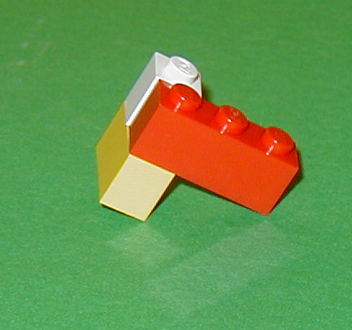
3. Place 3x1 horizontal. Place 3x1 so that left circle is over bottom circle of 2x1.

4. Turn a second 2x1 vertical. Attach bottom circle under right circle of 3x1.

5. Turn L piece like this:

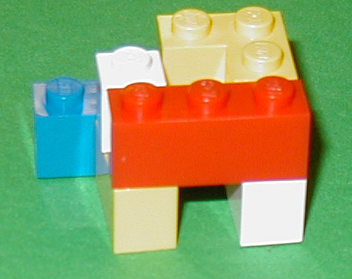

Attach bottom circle of L piece over top circle of 2x1.

6. Turn 4x 1 horizontal. Attach right two circles under top two circles of L piece.

7. Attach 2x2 over left two circles of the 4x1 piece.

8. Place 4x2 sheet horizontally. Place right two circles of 4x2 over the two vertical circles of the L piece, parallel to the 3x1.

9. Place 2x1 vertically over right two circles of the 4x2 sheet.

10. Place roof piece vertically over top of 2x1, so that the slanted part is towards the center of the molecule (over the third row of the 4x2 sheet).

The completed normal enzyme:
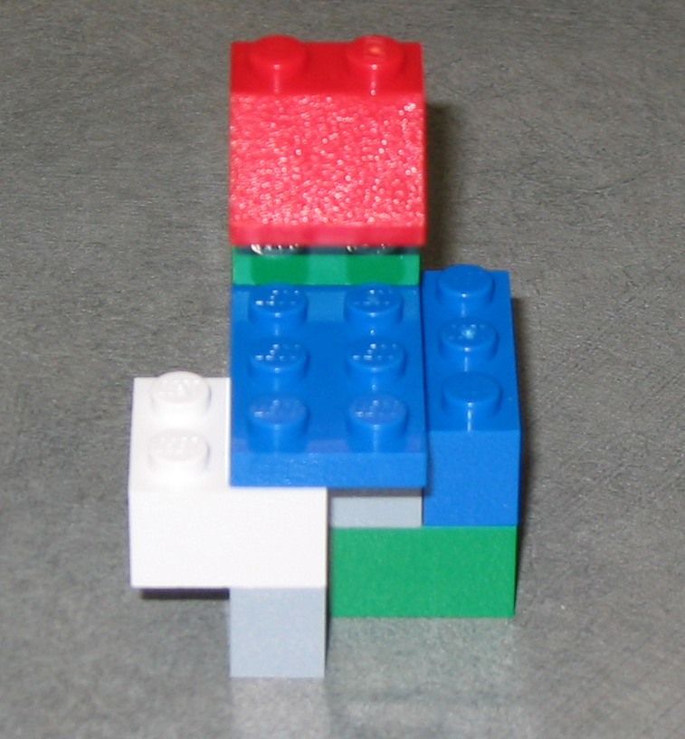
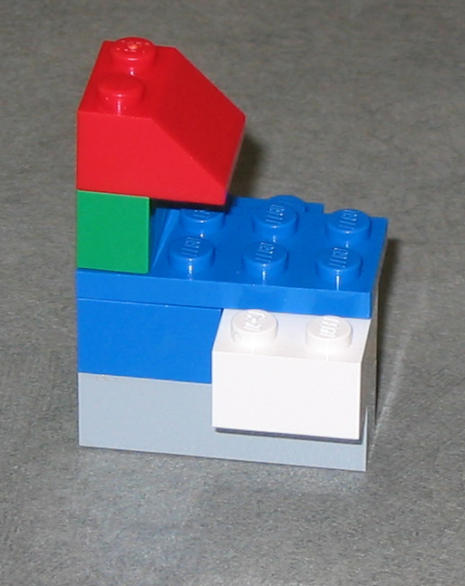
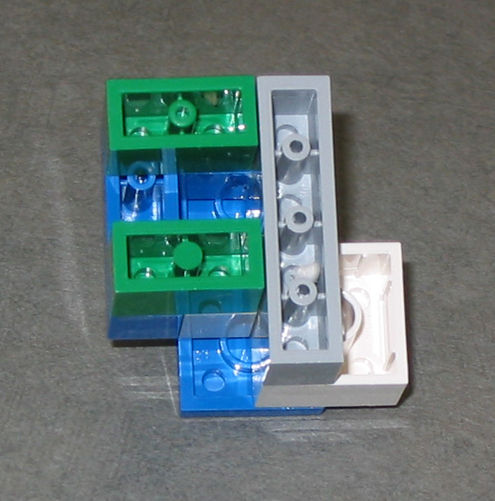

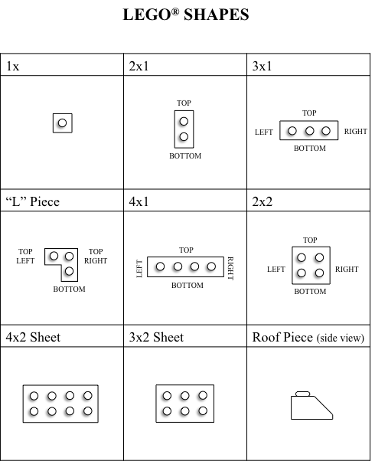
Packing List – Make sure that you have all these pieces before and after the lab!
1x
2x2
One: One:

Four:
2x1

One:
4x2 SHEET:
3x1
Two:

4x1
Two:
One: Roof piece, side view:
One: 6x1

One: assembled substrate:
One:
“L” PIECE

Packing List – Make sure that you have all these pieces before and after the lab!
2x2
One: One:
1x

Four:
2x1

One:
4x2 SHEET:
3x1
Two:

4x1
Two:
One: Roof piece, side view:
One: 6x1

One: assembled substrate:
One:
“L” PIECE

