Student Name: ____________________
Date: ____________________

Station 1: Fingerprints

- How do forensic scientists actually find fingerprints at a crime? Follow the directions to “lift” your own fingerprint from a glass surface.

Tape your fingerprint in the box:

Using the Fingerprinting Types sheet and a
magnifying lens, identify the patterns in your
fingerprints.

What type of fingerprint are you?
________________________________

- Three different fingerprints labeled “evidence” were taken from the glass cabinet in which the Diamond-Maker was locked up. Compare them to the fingerprints taken from each of the five suspects and Dr. Suzy Squeeze herself.

Fill in the chart below:

Fingerprint Evidence | Matching Fingerprint
1
2
3

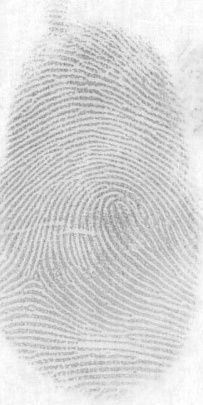
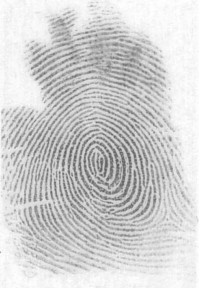
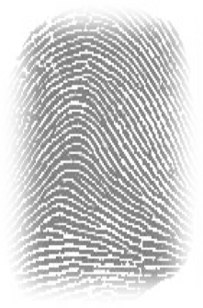

Evidence 1 Evidence 2 Evidence 3

Station 2: Chromatography

Follow the directions at the station to identify which suspect’s pen was used to write the note that was taped to Dr. Suzy Squeeze’s lab door.

Tape the result of your chromatography test below, and then color in the results of your group mates. Compare them to the evidence.

Dr. Evil (A) Sandra (B) Malcolm (C) Randy (D)

1. To whom does the matching pen belong? ____________________________

2. How important do you think this particular piece of evidence is? Explain.
________________________________________________________________
________________________________________________________________
________________________________________________________________
________________________________________________________________
________________________________________________________________

Station 3: Fiber Analysis

Some clothing fibers were found at the crime scene. Try to match the fibers to the clothing samples taken from the suspects:

Suspects | Fiber Color(s) and Pattern(s)
Maria
Randy
Sandra
Malcolm
Dr. Evil
Dr. Suzy Squeeze
Evidence 1
Evidence 2

3. Which suspects’ clothing best matches the fibers found at the crime scene?
________________________________________________________________
4. Is either one of these findings particularly suspicious to you?
________________________________________________________________

Station 4: Smells

Some paper towels were found in the trash at the lab. They smelled strongly of perfume/cologne.

5. Which suspect’s perfume/cologne best matches the one found at the lab?
________________________________________________________________
6. Look at the suspects’ cards. What is a possible explanation for this
particular finding?
________________________________________________________________

Station 5: Spilled Liquid

Some liquid was recovered from a lab table the night of the crime. The pH of the liquid found was 3. Measure the pH of the evidence and compare it to the favorite drinks of the suspects. Write any additional observations on these drinks.

Liquid | pH
Evidence | pH = _3_
Dr. Evil’s AlkaSeltzer | pH = ___
Malcolm’s Gatorade | pH = ___
Maria’s Water | pH = ___
Sandra’s Orange Juice | pH = ___

7. Whose drink was found at the scene of the crime? _____________________

8. Look at the suspects’ cards. What is a possible explanation for this
particular finding?
________________________________________________________________

Station 6: Powders

There are many different kinds of white powders—but only one was found at the crime scene! Fill in the chart below to see what kind of powder it is.

Substance | Appearance Under Magnification | Texture | Reaction to Water | Reaction to Vinegar
Powdered Sugar
Baking Soda
Baking Powder
Evidence | White, fine powder | Silky, sticks to fingers | None, dissolves | None, dissolves

Look at all your notes from Station 6 and answer the following questions:

9. What is the mystery powder? ______________________________________

10. Who do you think spilled the powder in the lab? _______________________

11. Look at the suspects’ cards. What is a possible explanation for this particular
finding?

Organizing the Evidence

Put a check mark in the box if the evidence matches the suspect:

Suspect | Fingerprint | Chromatography | Fibers | Smells | Drink | Powder
Malcolm
Randy
Sandra Dee
Dr. Evil
Maria
Dr. Suzy Squeeze

Use the space below to add any notes or important details from your group or class discussion:

______________________________________________________________________
______________________________________________________________________
______________________________________________________________________
______________________________________________________________________
______________________________________________________________________
______________________________________________________________________
______________________________________________________________________
______________________________________________________________________
______________________________________________________________________
______________________________________________________________________
______________________________________________________________________

Evaluating the Evidence – Final Detective Report

- Who do you think stole the Diamond-Maker?
___________________________________________________________________
- What evidence supports your theory?
___________________________________________________________________
___________________________________________________________________
___________________________________________________________________
___________________________________________________________________
___________________________________________________________________
___________________________________________________________________
___________________________________________________________________

- Is there evidence that does not support your theory? Explain.
___________________________________________________________________
___________________________________________________________________
___________________________________________________________________
___________________________________________________________________
___________________________________________________________________
___________________________________________________________________

- Which do you think is the most important piece of evidence pointing to the suspect?
Explain why.
___________________________________________________________________
___________________________________________________________________
___________________________________________________________________
___________________________________________________________________

- What should be the next step for the detectives to take?
___________________________________________________________________
___________________________________________________________________
___________________________________________________________________

