Crickets’ Response to Light

Name: _____________________________
Hypotheses
1. Write a prediction about whether the crickets will prefer light or dark places. Make sure you have a good reason to help explain your choice. Your hypothesis will read, somewhat, as follows: “The crickets will prefer ___ because___.” Write down your hypothesis here:
____________________________________________________________________________________
____________________________________________________________________________________
____________________________________________________________________________________
2. Given two different colored areas, make a prediction about which area the crickets will prefer. Make sure you have a good reason to help explain your choice. Your hypothesis will read, somewhat, as follows: “The crickets will prefer the ___ area because___.” Write down your hypothesis here:
____________________________________________________________________________________
____________________________________________________________________________________
____________________________________________________________________________________
Materials

- Transparent plastic container
- Mesh (to cover container so crickets can’t escape)
- Several crickets
- Laminated black construction paper, ½ the size of the container
- Small lamp
- Two different colors of transparencies
- Stopwatch

Procedure
1. Place several crickets in the plastic container.
2. Cover the container with mesh so the crickets cannot escape. Give the crickets a couple of minutes to get used to their new container.
3. Place black construction paper over half of the container.
4. Shine the light on the other side of the container. Be sure the light is far enough away so the crickets do not become too warm and heat does not play a factor in the experiment (approximately 60 cm is a good distance).
5. Every minute, for the next five minutes, count the number of crickets on either side of the container. Observe the container by looking down from above into the top middle of the container. Do not observe looking through the sides. See Figure 1 below. Record in Table 1 (Trial 1).
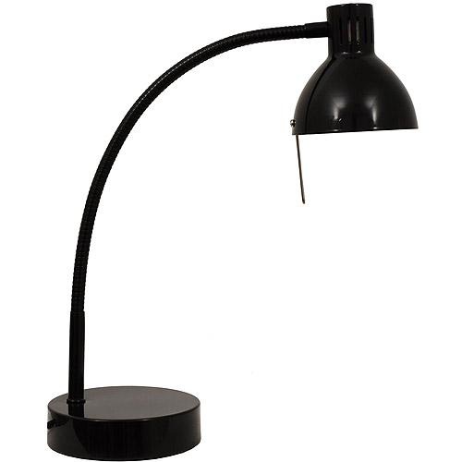
Container
Crickets
Black Paper
Lamp

Figure 1. Observation technique
6. Switch the positions of the light and the black paper, so the black paper is now on the spot where the light was. The light will now be shining on the spot where the black paper was before. Give the crickets a couple of minutes to adjust to the new set-up.
7. Every minute, for the next five minutes, count the number of crickets on either side of the container. Observe the container by looking down from above into the top middle of the container. Do not observe looking through the sides. See Figure 1. Record in Table 2 (Trial 2).
8. Remove black construction paper.
9. Place the two different colors of transparencies you chose over both halves of the container. Do not overlap them. See Figure 2. Give the crickets a couple of minutes to adjust to the new set up, or wait until the teacher tells you to being observing the crickets.
Colored Transparencies

Container
Crickets

Figure 2. Crickets and light preference setup

10. Every minute, for the next five minutes, count the number of crickets on either side of the container. Just like before, observe by looking down from above into the top middle of the container. Again, do not observe looking through the sides. Record in Table 3 (Trial 1).
11. Switch the positions of the colors so they are now on the opposite half. Give the crickets a couple of minutes to adjust to the new set up, or wait until the teacher tells you to begin observing the crickets.
12. Every minute, for the next five minutes, count the number of crickets on either side of the container. Observe the container by looking down from above into the top middle of the container. Do not observe looking through the sides. Record in Table 4 (Trial 2).
13. Put the crickets back into their habitat and clean up your supplies and workstation.
14. Answer all the questions in the Data and Analysis section.

Data and Analysis
Part I. Do crickets prefer lighter environments over darker environments?
Table 1. Crickets’ lighting preferences (Trial 1)
Time of Observation | Number of Crickets in the Light | Number of Crickets in the Dark
1 min
2 min
3 min
4 min
5 min
TOTALS
(add up the number of crickets for Light and Dark)

1. Add up all the numbers for Crickets in the Light and record under TOTALS. Add up all the numbers for Crickets in the Dark and record under TOTALS. Compare these totals. Do the crickets prefer light or dark? __________ Support your answer with data from the experiment.
____________________________________________________________________________________
____________________________________________________________________________________
____________________________________________________________________________________
____________________________________________________________________________________

Table 2. Crickets’ lighting preferences (Trial 2)
Time of Observation | Number of Crickets in the Light | Number of Crickets in the Dark
1 min
2 min
3 min
4 min
5 min
TOTALS
(add up the number of crickets for Light and Dark)

2. Add up all the numbers for Crickets in the Light and record under TOTALS. Add up all the numbers for Crickets in the Dark and record under TOTALS. Compare these totals. Do the crickets prefer light or dark? __________

3. Compare the TOTALS from Trial 1 and Trial 2. What can you conclude from these trials? Use your data to answer this question.
____________________________________________________________________________________
____________________________________________________________________________________
____________________________________________________________________________________
____________________________________________________________________________________
____________________________________________________________________________________

Part II. Do crickets have a preference for color?
Table 3. Crickets’ color preferences (Trial 1)
Time of Observation | Color 1: _____________ Number of Crickets Under  This Color | Color 2: ______________ Number of Crickets Under  This Color
TOTALS
(add up the number of crickets for each color)

4. Add up all the numbers for Crickets Under Color 1 and record under TOTALS. Add up all the numbers for Crickets Under Color 2 and record under TOTALS. Compare these totals. Do the crickets prefer one color over the other? __________ Which color do they seem to prefer? __________ Use your data to answer this question.
____________________________________________________________________________________
____________________________________________________________________________________
____________________________________________________________________________________
____________________________________________________________________________________

5. The larger the difference between the two TOTALS, the higher the preference crickets have for a color. So far, what can you conclude from these results?
____________________________________________________________________________________
____________________________________________________________________________________
____________________________________________________________________________________

Table 4. Crickets’ color preferences (Trial 2)
Time of Observation | Color 1: _____________ Number of Crickets Under  This Color | Color 2: ______________ Number of Crickets Under  This Color
TOTALS
(add up the number of crickets for each color)

6. Add up all the numbers for Crickets Under Color 1 and record under TOTALS. Add up all the numbers for Crickets Under Color 2 and record under TOTALS. Compare these totals. Do the crickets prefer one color over the other? __________ Which color do they seem to prefer? __________ Use your data to answer this question.
____________________________________________________________________________________
____________________________________________________________________________________
____________________________________________________________________________________

7. Compare the TOTALS for each color for both trials. Because you switched the position of the colors on top of the container, make sure that you recorded the data accurately. The larger the difference between the two TOTALS, the higher the preference crickets have for a color. What can you conclude from your results? Use your data to answer this question.
____________________________________________________________________________________
____________________________________________________________________________________
____________________________________________________________________________________

Discussion
- Using information from your data tables, explain what conclusions you can draw about crickets preferring dark or light areas.
__________________________________________________________________________________________________________________________________________________________________
_________________________________________________________________________________
_________________________________________________________________________________
- Go back to Page 1 and re-read your hypotheses. Does your data support your first hypothesis (about light vs. dark)? Does your data support your second hypothesis (about color preferences)?
__________________________________________________________________________________________________________________________________________________________________
_________________________________________________________________________________
_________________________________________________________________________________
- In both Part I and Part II we switched the position of the paper, the light, and the transparencies after one trial. Explain why this simple procedure made your data more accurate.
__________________________________________________________________________________________________________________________________________________________________
_________________________________________________________________________________
_________________________________________________________________________________
- How can the results of this lab influence where we place our cricket habitat in our classroom?
__________________________________________________________________________________________________________________________________________________________________
_________________________________________________________________________________

