DNA notes

To run an organism and to be the “molecule of heredity”, DNA has two main jobs or functions:

1) it must somehow encode the information for all structural and functional features of cells. What does this mean?

2) It must furthermore be able to insure that identical copies are passed to each of the daughter cells during cell division, so it must be able to:

I. What is the physical structure of DNA?
A. The chemical units that make up DNA are called :

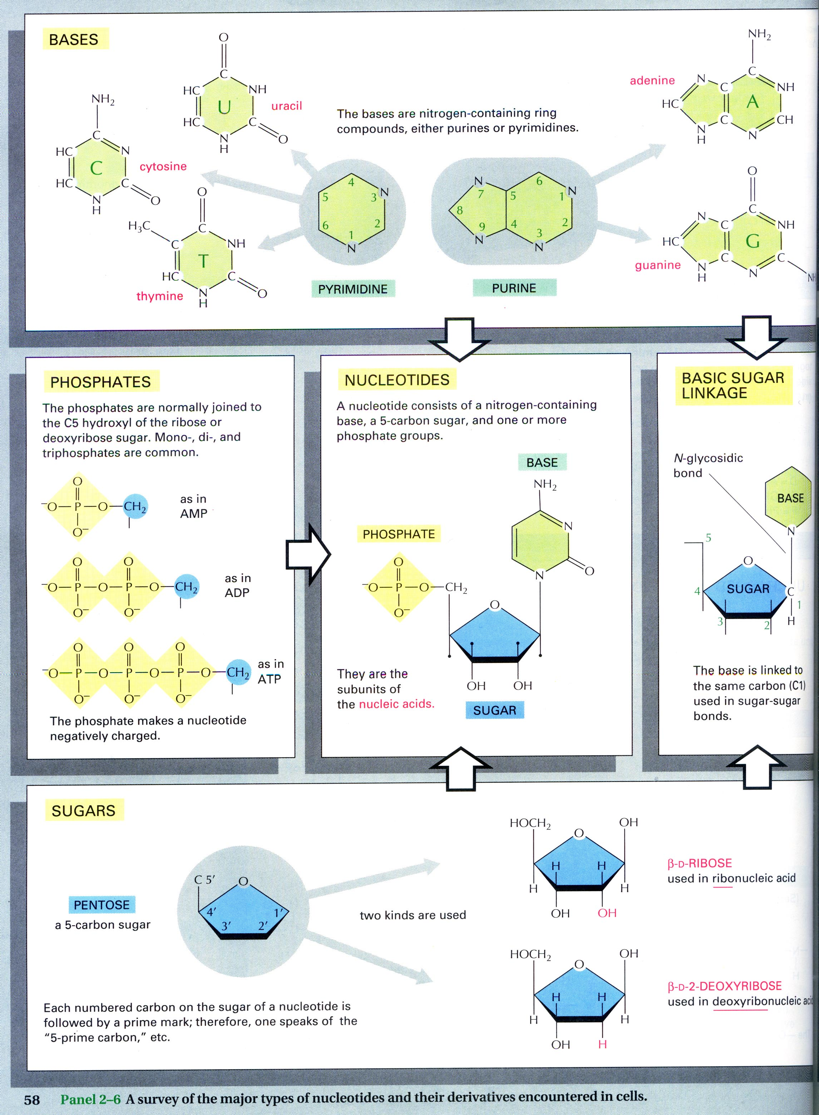
Nucleotides have THREE parts:

1.

2.

3.

Note that there are two types of bases (see the picture below) :

1)

and

2)

You might notice............the smaller name is the bigger molecule, and vice versa.

Pairing of the bases is always a purine + a pyrimidines

_______always pairs with ___________

and

________always pairs with __________

This is known as—Chargaff’s ratios.

ALSO:An important thing to know: Note the order in which the carbons are numbered in the sugar. The orientation of the sugar determines the directionality of the DNA molecule. This will matter later….

B. Nucleotides are joined by 5' to 3' phosphodiester linkages to form DNA. This is a very strong covalent bond.
A strand of DNA has a direction, which is determined by the orientation of the sugars
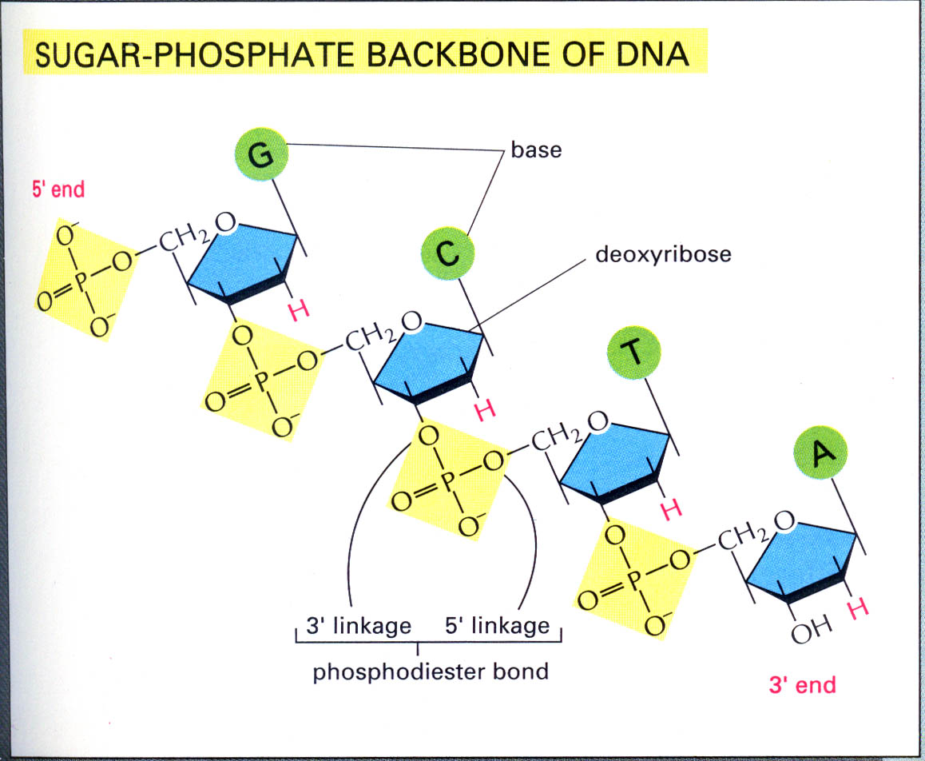

C. DNA is double stranded

1. the strands are anti-parallel, which means:

2. Two strands can come apart for DNA to perform its functions. The hydrogen bonds (which are not ‘real’ bonds, but are attractions between the bases) allow this to happen.

II. What are some specific functions of DNA other than coding for proteins and copying itself?

A. Some DNA has a structural role. Each eukaryotic chromosome must contain one centromere and telomeres at either end. These sequences are important for DNA replication and cell division but do not have a coding function.

B. MOST functional DNA is transcribed into one of three types of RNA

DNA→RNA--______________-->_________________

C. Some DNA has a regulatory function. It is able to turn some genes on while others remain off. Every somatic cell in a multicellular organism contains the same DNA yet cells specialize into tissues, organs, etc. This is achieved by selective expression of specific genes in specific cell types.

D. Most of the genome is intergenic DNA (the DNA between genes) whose function is still largely unknown. It used to be called ‘JUNK’ DNA, but that name is going out of vogue, since scientists know the DNA must have a function, they just don’t know what it is yet in many cases.

