
Dichotomous Key Lab

Name:_______________________________________________
Date:___________________
Part 1. Pasta Feast
Your teacher will pass around the Pasta Types hand out. Your group will have 10 seconds to choose one type that seems interesting to you. Write down the name of the pasta and keep it from the teacher. Then cross it out in the Pasta Types hand out, so another group doesn’t choose the same type.

Your teacher will use the following key to identify the pasta of at least two groups. Follow along! The other groups will be called to identify the pasta type of another group. Be ready!

- The shape of the pasta is straight…………………………………………………………………….Go to #2
The shape of the pasta is not straight………………………………………………………………Go to #4

- The pasta is hollow..………………….…………………………………………………………………….Go to #3
The pasta is not hollow..…….…………………………………………………………………………spaghetti

- The pasta is smooth………………………………………………………………………………………………..ziti
The pasta is not smooth…………………………………………………………………………..penne rigate

- The pasta is round…………………..………………………………………………………………………..rotelle
The pasta is not round…………………………………………………………………………………….Go to #5

- The pasta has two lobes………………………………………………………………………………..farfalline
The pasta does not have two lobes…………………………………………………………….campanelle
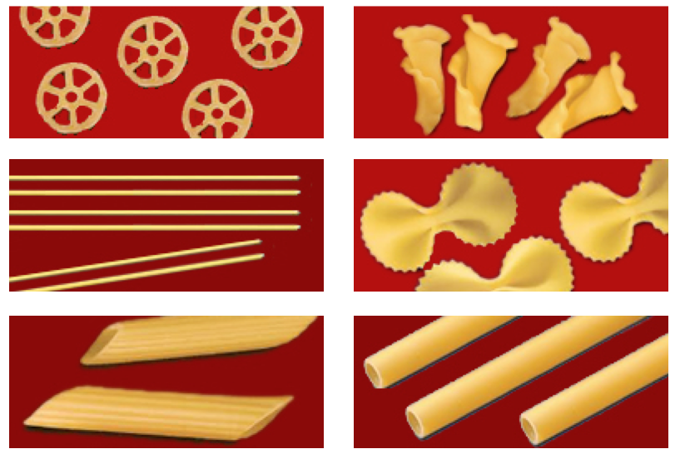

Your teacher used a dichotomous key to identify the pasta. Answer the following questions:

1. Describe the process your teacher used to identify the pasta types:
_________________________________________________________________________________________________________
_________________________________________________________________________________________________________
_________________________________________________________________________________________________________
_________________________________________________________________________________________________________
_________________________________________________________________________________________________________
2. Explain in your own words what a dichotomous key is: _______________________________________
_________________________________________________________________________________________________________
_________________________________________________________________________________________________________
_________________________________________________________________________________________________________
Part 2. Dichotomous Keys
The variety of living organisms on our planet is amazing. From microscopic bacteria, to maple trees, to the gigantic blue whales that inhabit our oceans…Organisms that share certain characteristic are classified into groups. Two major groups (or kingdoms) you are familiar with are the Kingdom ‘Animals’ and the Kingdom ‘Plants’. But not all animals are alike, so within this large group, they are classified into smaller categories, using characteristics: such as having fur, having 6 articulated legs, having scales –and so forth.
In order to better understand how life on Earth is organized, and how organisms are related to each other, scientists have developed different ways to organize, or classify, all the different living creatures. One of these systems is a tool called a ‘dichotomous key.’ The word dichotomous means “divided into two parts”. A dichotomous key is a tool that provides the reader with two statements (choices) that describe characteristics about items or living organisms. These statements help the reader to classify and identify the items. With a dichotomous key, you choose between two clear physical characteristics that the organism possesses or not, and move down a chart (or tree) or a list until you finally can identify it. On the next page you will find a ‘classification tree’ for different balls used to play different sports.
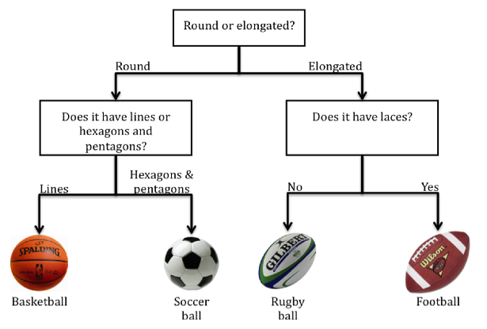

Answer the following questions:

What is the major group to which all these items belong? What makes them be grouped into a single category?

______________________________________________________

In this example, what separates them into two major groups? __________________________________
_________________________________________________________________________________________________________

According to this classification tree, list three characteristics that differentiate a soccer ball from a football:

1. _______________________________________________________________________________________
2. _______________________________________________________________________________________
3. _______________________________________________________________________________________

But sometimes, instead of using ‘classification trees’ like the one on the last page, scientists use lists to convey the same information. For this example, the list would look like this:

1a. Ball is perfectly round and spherical……………………………………………go to (2)
1b. Ball is not round and spherical……………………………………………………go to (3)

2a. Ball has hexagons and pentagons on it……………………………………soccer ball
2b. Ball doesn’t have hexagons and pentagons on it…….……….....……basketball

3a. Ball has one side with laces……………………………………………………..…football
3b. Ball has no laces…………………………………………………….……………….rugby ball

Using this list, write down two characteristics that differentiate a football from a basketball:

1. _______________________________________________________________________________________
2. _______________________________________________________________________________________

Next, it will be your turn to make a dichotomous key to
classify a particular group of 6 organisms.

Part 3. Making Your Own Dichotomous Key
Obtain a large card with the pictures of 6 organisms, plus the six individual pictures of the same organisms. BEFORE YOU START, MAKE SURE THAT THE ORGANISMS ON THE LARGE CARD AND THOSE ON THE INDIVIDUAL CARDS ARE ALL THE SAME!

Using an oversize piece of newsprint paper, a marker or a pen, and a ruler, make a classification tree for the organisms on your card. Use the classification tree for the sports balls on Page 4 as your guide. However, notice that you were assigned 6 organisms, so your tree will be larger.
As you decide on which characteristic to use, remember to use constant characteristics rather than ones that disappear or vary with the season or other environmental factor. For example, the snowshoe hare is completely white in the winter, but brown during the warmer months.
Also, use characteristics that can be directly observed. And if you are going to use a quantitative measurement, use a definite amount (for example: 2 legs, 4 legs, 6 legs). Avoid using terms such as "big" and "small” which are vague.
Next, turn your ‘classification tree’ into a ‘list’, or dichotomous key on the next page. Use the sports balls key as an example, but remember that your key will be longer because you have 6 organisms to classify and not just the 4 sports balls. Do not forget to write the words ‘go to #_____’ when necessary.
1a. _____________________________________________________________________________________
1b. _____________________________________________________________________________________

2a. _____________________________________________________________________________________
2b. _____________________________________________________________________________________

3a. ______________________________________________________________________________________
3b. ______________________________________________________________________________________

4a. _____________________________________________________________________________________
4b. _____________________________________________________________________________________

5a. _____________________________________________________________________________________
5b. _____________________________________________________________________________________

6a. _____________________________________________________________________________________
6b. _____________________________________________________________________________________

7a. _____________________________________________________________________________________
7b. _____________________________________________________________________________________

8a. _____________________________________________________________________________________
8b. _____________________________________________________________________________________
9a. _____________________________________________________________________________________
9b. _____________________________________________________________________________________

The following questions are in the style of the NYS Regents Exam. Answer them on your own, or discuss them with your group.

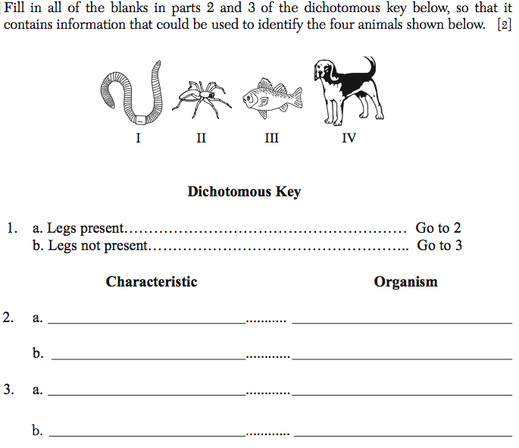
A.

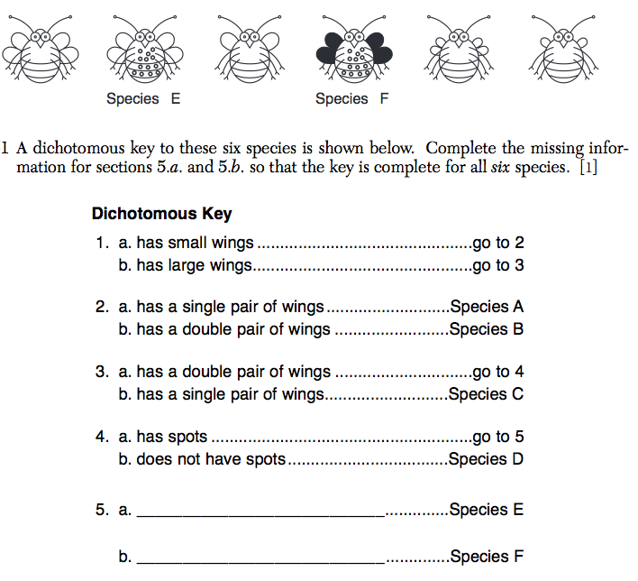
B.

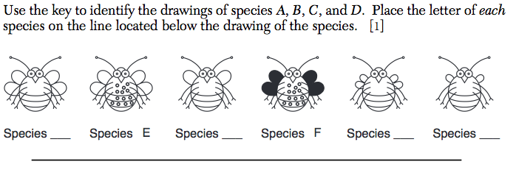
C.

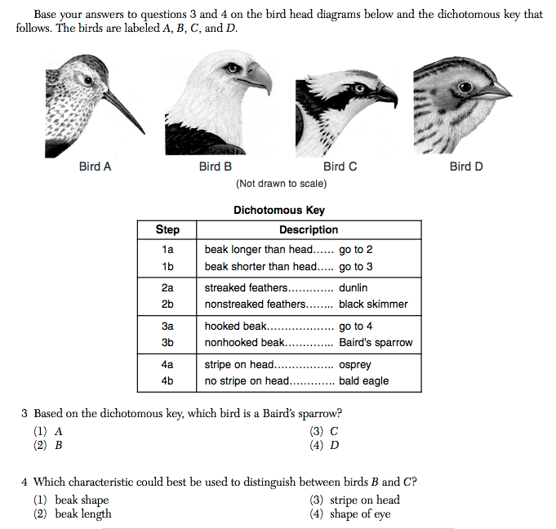
D.

http://io9.com/5959772/how-and-why-animals-change-color-with-the-seasons

http://www.nysedregents.org/grade8/science/613/ils62013-exam.pdf

http://regentsprep.org/Regents/biology/units/laboratory/dichotomous.cfm

http://web.stanford.edu/group/lpchscience/cgibin/wordpress/images/Taxonomy-T.pdf

http://lecoursedebiase.com/Dichotomous.html

http://www.jmap.org/JMAP/IJMAP/LivingEnvironment/RegentsExams/0609ExamLE.pdf

