Getting to Know Your Cricket | 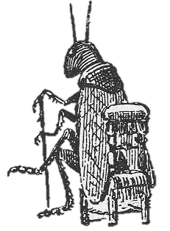
Name: _____________________________________ Date: ___________
Background Information
Crickets are primarily nocturnal. In nature they are found in tall grass, leaf piles, weeds, rock piles, and rotting logs. Meadows, pastures, and roadsides are all common places to find them. Some crickets spend their entire lives inside buildings and basements, in warm places where there is enough moisture and food, under objects and in crevices. They are ectotherms, or variable-temperature animals. This means that their body temperature changes according to the surrounding temperature. Crickets are omnivores, and they also scavenge for dead insects and decaying material. Birds, rodents, reptiles, insects (including beetles and wasps), and spiders are among crickets’ main predators.
Crickets undergo incomplete metamorphosis. They hatch from eggs that the female deposits in soil using her ovipositor. Immature crickets (called nymphs) look like small adults, but the wings and ovipositors are not fully developed. They molt many times as they develop into adults.
Crickets have both positive and negative ecological effects. They help break down plant material, which increases soil quality, and they are an important food source for many other animals. However, large numbers of crickets can be destructive. They injure tree seedlings, and the males’ songs are very loud.
Adult males of most cricket species begin to chirp when they are six to eight weeks old. They chirp by rubbing their forewings together. This process is called stridulation. The adult male stridulating organ consists of a smooth scraper on one forewing that is drawn across a serrated file on the other forewing to produce a song. Because crickets spend most of their time hidden in the grass or under leaves and almost never see each other, sound is one of their most important communication tools.
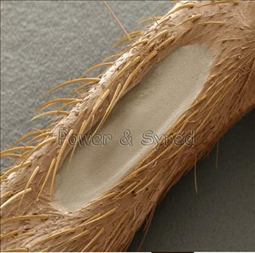
Male field crickets (the type you may find in your backyard) have at least three songs: one that attracts females, one that woos the female after he gets her attention, and one that warns other males to back off. Some males use the chirping sounds to mark their territory. Crickets can also disguise their “voices” when in danger. By lowering his “voice,” a cricket can make himself sound far away. Chirping patterns are specific to each species and females respond only to the song of their own species.
Figure 1. Female cricket’s “ear.”
Females hear the males through a small pit or depression on the front side of the leg, which has a thin membrane stretched over it like a drum (Figure 1). This “ear” picks up the vibrations of the chirps and helps the females find the males.
Habitat Design
Based on what you now know about crickets’ food, temperature, and light preferences, design an appropriate habitat for your crickets. Use a separate sheet of paper to either describe it or draw and label it.
Anatomy
Read the following descriptions of a cricket’s body parts, then label the diagram:

Abdomen- The segmented tail area of a cricket, which contains the heart, reproductive organs, and most of the digestive system.
Antennae- Like all insects, crickets have two segmented antennae that sense touch and odors.
Cerci- This pair of sensory organs located at the rear of the abdomen (the singular of cerci is cercus) is typically larger in males.
Compound Eye- Crickets have two faceted eyes made up of many hexagonal lenses.
Forewings- The pair of wings closest to the head.
Head- The head is at the front end of the cricket's body and is the location of the brain, the two compound eyes, the mouthparts, and the points of attachment of its two antennae.
Hind wings- The pair of wings farthest from the head.
Jumping Legs- The long, hindmost pair of the cricket's six legs,
Mouth- located on the head near the palps.
Ovipositor- A reproductive organ located at rear of the female's abdomen (between cerci).
Palps- Long, segmented mouth parts (under the jaws) that grasp the food.
Simple Eye- Small, primitive organs that distinguish dark from light.
Spiracles- A series of holes located along both sides of the abdomen; they are used for breathing.
Thorax- The middle area of the cricket's body, where the legs and wings are attached.
Walking Legs- The four, short front legs that are used for walking.

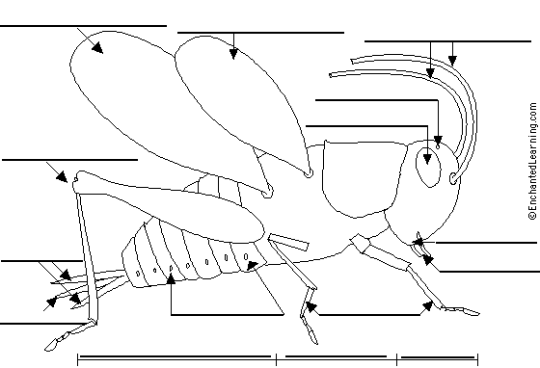
Feeding Observations
Select an individual cricket to observe. Spend a few moments watching your cricket eat, using a magnifying glass. Write a description of how it eats:
________________________________________________________________________________________________________________________________________________________________________________________________________________________________________________________________________________________________________________________
Is My Cricket Male or Female?
Though both males and females have two cerci, only females have an ovipositor. It may look like a third cerci, or appear to be a different length. Female crickets use this organ to lay eggs into the soil. Only male crickets chirp—they do this to attract a female mate.
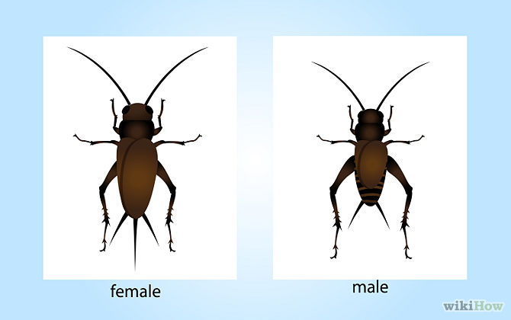
Ovipositor
Female | Male

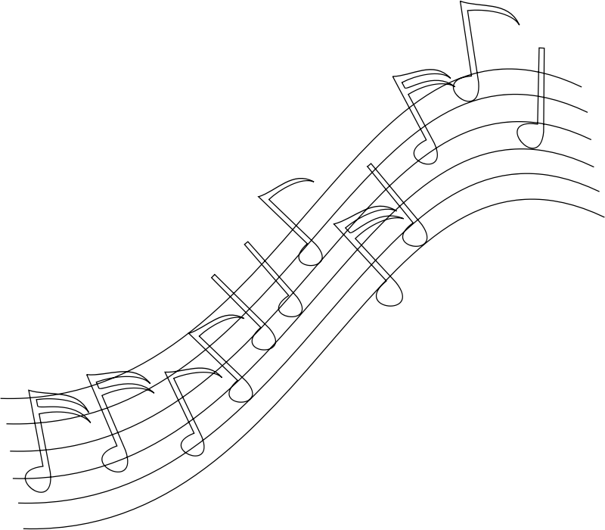

Other Activities

Research crickets in various places, times, and cultures. Sometimes they are kept as pets because people enjoy their songs. Cricket fighting (watching two male crickets fight) is a popular, ancient Chinese pastime. In some parts of the world, crickets are fried and sold as snacks!
  McKay Savage, Wikipedia Commons.  Pet cricket with cricket house made of a gourd. China. |   Deep fried crickets for sale at a market in Cambodia. | 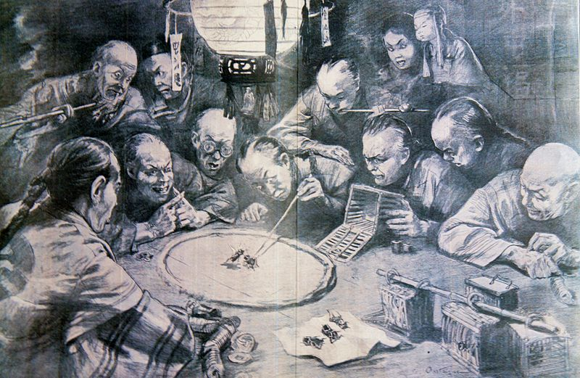  Dutch representation of cricket fighting in China.

Go online and check out http://www.hup.harvard.edu/features/cricket-radio/ to make your own Cricket Radio!

Henry David Thoreau was a famous American naturalist and poet of the 1800s. Read what he wrote about crickets in his journal on August 21, 1851:

“I hear a cricket in the Depot field, walk a rod or two, and find the note proceeds from near a rock. Partly under a rock, between it and the roots of the grass, he lies concealed,—for I pull away the withered grass with my hands,—uttering his night-like creak, with a vibratory motion of his wings, and flattering himself that it is night, because he has shut out the day. He was a black fellow nearly an inch long, with two long, slender feelers. They plainly avoid the light and hide their heads in the grass. At any rate they regard this as the evening of the year. They are remarkably secret and unobserved, considering how much noise they make. Every milkman has heard them all his life; it is the sound that fills his ears as he drives along. But what one has ever got off his cart to go in search of one? I see smaller ones moving stealthily about, whose note I do not know. Whoever distinguished their various notes, which fill the crevices in each other’s song? It would be a curious ear indeed, that distinguished the species of the crickets which it heard, and traced even the earth-song home, each part to its particular performer. I am afraid to be so knowing. They are shy as birds, these little bodies. Those nearest me continually cease their song as I walk, so that the singers are always a rod distant, and I cannot easily detect one. It is difficult, moreover, to judge correctly whence the sound proceeds. Perhaps this wariness is necessary to save them from insectivorous birds, which would otherwise speedily find out so loud a singer. They are somewhat protected by the universalness of the sound, each one’s song being merged and lost in the general concert, as if it were the creaking of earth’s axle.”

Sources
http://insected.arizona.edu/cricketinfo.htm
http://www.mrnussbaum.com/insects-play/crickets/
http://www.enchantedlearning.com/subjects/insects/orthoptera/Cricket.shtml

