Name: ___________________________________________ Date: ___________
Metric Measurement | 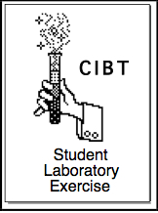

The Metric System, also called the International System of Units, or SI system, has basic units that you might have heard about:
- Meter (m) for length
- Gram (g) for mass
- Second (s) for time
- Liter (l) for volume
- Celsius (°C) for temperature
Which of these units have you heard about before and where?
______________________________________________________________________________________________________________________________________________________________________________________________________________________________________________________________________________________________________________________________________________________________________________________________________
This is the “universal language of measurement” for all countries, and the only system used in science. All the measurements that you will be required to make on this lab will be SI measurements. You will be measuring length of hands and feet and even comparing different species. The results might surprise you!

Materials
- Several printouts or models that your teacher will provide
- Metric ruler

Procedure
Part 1: Hands and Feet
In the first part of this lab you will compare human hands to human feet.
In humans, what is longer: a hand or a foot? ___________________________.
Which one do you think has more bones than the other? ____________________________.
What makes you think this? _______________________________________________________ ______________________________________________________________________________
______________________________________________________________________________
- Look at the diagram of the hand in the green print out. Count the number of bones present in the thumb, fingers, palm and wrist (they are shaded in different ways in the diagram to help you.) Record your counts on Table #1.
- Look at the diagram of the foot on the blue print out. Count the number of bones present in the big toe, other toes, center of the foot, ankle and heel. Record data in Table #1.
- Count all the bones in the hand and all the bones in the foot and enter these numbers in Table #1.
TABLE #1. Bone count comparison between a human hand and a foot.
BONE COUNTS
Hand | Number of bones in… |  | Foot | Number of bones in…
The thumb |  |  | The big toe
All other fingers |  |  | All other toes
Palm of hand |  |  | Center of foot
Wrist |  |  | Ankle and heel
TOTAL |  |  | TOTAL

For the following measurements, round numbers to the nearest 10th, or millimeter. All these results will be recorded on Table #2.
- Measure in millimeters the lengths of the bones marked A, B, C, D, and E on the hand diagram. Record your measurements in Table #2.
- Measure in millimeters the lengths of the bones marked A, B, C, D, and E on the foot diagram. Record your measurements in Table #2.
- Measure the length of the thumb and record the number in Table #2.
- Measure the length of the big toe and record the number in Table #2.
- Measure the lengths of the smallest finger and toe and record the number in Table #2.
- Change all the millimeter measurements to centimeter measurements in Table #2. Remember: there are ten millimeters in one centimeter (1 cm = 10 mm).
TABLE #2. Bone length comparison between fingers and toes.
BONE LENGTHS
BONE | HAND |  | FOOT
BONE | MILLIMETERS | CENTIMETERS | MILLIMETERS | CENTIMETERS
Bone A
Bone B
Bone C
Bone D
Bone E
Length of thumb or big toe
Length of smallest finger or toe

Question #1. Complete the Venn diagram below. Find some characteristics that are unique to the hand and foot, and others that they have in common.

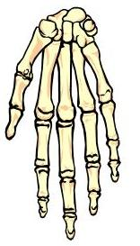
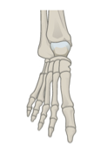
- _______________________________________
- _______________________________________
- _______________________________________
- _______________________________________
- ___________________________________________________
- _______________________________________
- _______________________________________
- _______________________________________
- _______________________________________
- ___________________________________________________
- _______________________________________
- _______________________________________
- _______________________________________
- _______________________________________
- _______________________________________
Question #2. Using the information in your data tables, describe the main differences between the lengths of the bones in the hand and the foot.
______________________________________________________________________________________________________________________________________________________________________________________________________________________________________________________________________________________________________________________________________________________________________________________________________

Question #3. Why do you think feet are larger than hands in humans?
______________________________________________________________________________________________________________________________________________________________________________________________________________________________________________________________________________________________________________________________________________________________________________________________________

Part 2. Humans and Another Species
In Biology, ‘the great apes’ include orangutans, bonobos, gorillas, chimpanzees and humans. They are all in the family Hominidae because in the distant past they all shared an ancestor. We all still have many features in common in spite of the obvious differences among us.

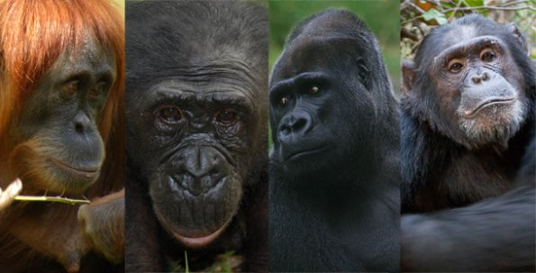

http://theadvancedapes.com/201328great-ape-and-human-genetic-diversity/
For this part of the Lab you will need to use the yellow handouts. Return the green and blue handouts to your teacher. Exchange them for the two yellow pages. Locate the 3 diagrams that you will be working with at about the same time (the large yellow handout is double sided):
- Large size yellow handout. Side A: Disarticulated orangutan hand
Side B: Print of an orangutan hand
- Half-page yellow handout. Disarticulated human hand

- Look at Side A in the long, yellow handout. You will use this printout to complete the information requested in Table #3.
- Fill out the rest of Table #3 using the small yellow handout with the disarticulated human hand.
Predict: Which hand do you think is made up of more bones: the human hand or the orangutan’s hand?
_________________________________________________________
TABLE #3. Comparison of a human and orangutan hand.

How many fingers are in the orangutan hand?______
How many fingers are in the human hand? ________

ORANGUTAN HAND |  | HUMAN HAND
Number of bones in the thumb |  | Number of bones in the thumb
Number of bones in the other fingers |  | Number of bones in the other fingers
Number of bones in the rest of the hand |  | Number of bones in the rest of the hand
Total number of bones in the hand |  | Total number of bones in the hand
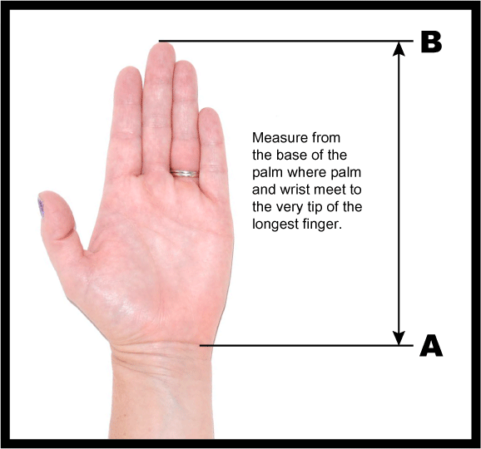
- Using centimeters, measure the length of your own hand from the base of your palm, to the tip of the longest finger. See the picture on the side for reference. Enter this information in the space below.
Length of your hand: ________________________
- Locate the print of the orangutan hand on Side B in the long yellow handout. Using centimeters and following the same procedure you did for #3, measure the length of the orangutan hand. Enter this information in the space below.
Length of the orangutan hand: ___________________
How many centimeters longer is the orangutan hand? ______________

Question #4. How do the hands of humans and orangutans compare to each other?
______________________________________________________________________________________________________________________________________________________________________________________________________________________________________________________________________________________________________________________________________________________________________________________________________

Question #5. Which of these findings surprised you and why?
____________________________________________________________________________________________________________________________________________________________
____________________________________________________________________________________________________________________________________________________________
Question #6. The number of bones in the foot of a gorilla is the same as in humans and chimpanzees. Suggest why species that seem so different could share these similarities.
________________________________________________________________________________________________________________________________________________________________________________________________________________________________________________________________________________________________________________________
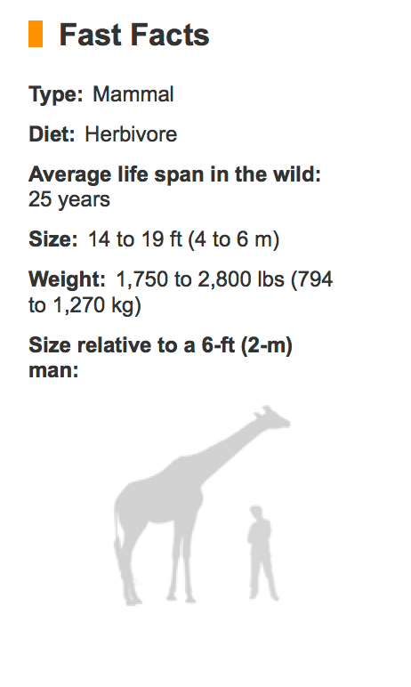
Question #7. The number of bones in the neck of a giraffe is the same as the number of bones in the neck of a human: each one has 7 vertebrae. Yet the giraffe is so much taller than a man. The average length of each the giraffe neck vertebrae is about 25 cm. The total length of the human neck is about 11 cm. How much longer than the average human neck is the neck of the giraffe? Show your work and use the proper unit.
_________________

What is the average length of the vertebrae in the human neck?
_________________

Question #8. Look at this chart of Fast Facts with general information about the giraffe. What is one characteristic we share with giraffes that could explain why both species have the same number of vertebrae in the neck? Use a complete sentence to answer this question.
_________________________________________________________________________________________________________________________________________________________________________________________________________________________________________
Question #9. The length of a human hand with all fingers extended is exactly the same as the length of the person’s face. How long is your face?
__________________________________ORANGUTANS
Once widespread throughout the forests of Asia, orangutans are now found on just two islands, Sumatra and Borneo. They are now highly endangered due to habitat loss and poaching.
Orangutans are the largest of all arboreal (tree-dwelling) animals. The males can reach 1.5 m and the females about 1.06 m. Males can weigh up to 140 kg, but the females only reach about half of that. Equipped with very long, powerful arms and hook-shaped hands and feet, these apes climb and swing from tree to tree with ease.
They reach from one tree to the next with their long arms, grasping the next branch with long hands or feet, and swing their bodies across the gap. If a baby following its mother reaches a gap between trees that is too wide for it to navigate, its mother makes a living bridge for the baby to scamper across. An orangutan’s arm span can reach more than 2.5 m!
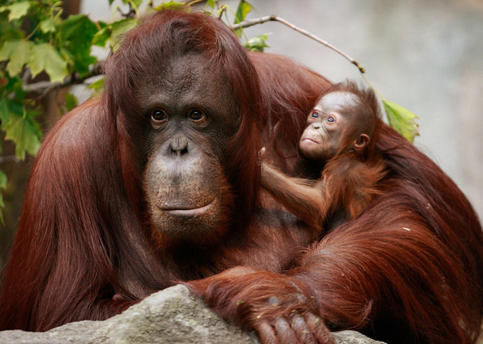
Orangutans find their food in the trees where they live. More than half their diet consists of fruit. They also eat nuts, bark, and other parts of plants and trees. Every once in a while they eat insects such as ants and termites, as well as bird eggs. Orangutans even find the water they need for drinking up in the trees—in hollows, on leaves, or even on their own fur after a rain.
Trees are essential to every aspect of the orangutans' world. The cutting down of trees—deforestation—has landed this species on the endangered species list.
(adapted from National Geographic Kids and SOS –Sumatran Orangutan Society.)
What advantages do long arms and hands give orangutans?
____________________________________________________________________________________________________________________________________________________________________________________________________________________________
Sophia, a 27 year-old Bornean orangutan, holds her newborn in her enclosure at Brookfield Zoo in Illinois, on October 23, 2008. The female infant was one of only two orangutan births expected in North American zoos that year. There are an estimated 61,000 orangutans remaining in the wild, a 50 percent decline since 1990. (www.zimbio.com).

Metric System Practice
Obtain the laminated pieces of paper from various lengths from your teacher. You need to have 6 pieces all together. Organize them in the following order, writing the color of the corresponding piece next to the right length. You do NOT need to use a ruler for this part. Each color represents a letter. Record the color and the corresponding letter below. What does it spell?
___________________________
Color: Letter:

- The piece with a length of 34 cm _______________________ ____________
- The piece with a length of 29 cm _______________________ ____________
- The piece with a length of 290 mm _______________________ ____________
- The piece with a length of 21 cm _______________________ ____________
- The piece with a length of 100 mm _______________________ ____________
- The piece with a length of 9 cm _______________________ ____________

Make the conversions below:
1 m = ______________ cm 1 cm = ____________ mm 1 m = ___________ mm
99 cm = ____________ mm 25 mm=____________ cm 4.9 cm=___________ mm
21 cm =____________ mm 80 mm=____________ cm 5.7 cm=___________ mm
320 cm=____________ mm 100 mm=____________ cm 140 mm =__________cm

On the sample ruler below, what measurements are represented by the letters b, c and d? BE CAREFUL WITH THE UNITS REQUIRED!
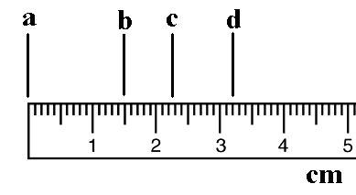
b = ________________ cm

c = ________________ cm

d = ________________ mm

Inferring Height from Humerus Length
Work with a partner. Measure each other using meter sticks, and write your partner’s height here:
____________________ cm.
- Identify the placement of your partner's humerus bone. It is the single large bone that extends from the elbow to the shoulder socket.
- Use a meter stick or measuring tape to determine the approximate length of this bone (in centimeters). Write it down here:
_________________ cm.
If the bone comes from a female subject, go to Step 3. If the bone comes from a male subject, go to Step 4.
- If the bone comes from a female, multiply the measured length in centimeters by 3.06.
Add 64.26 to this number. This final number is the approximate height of the female based upon her humerus length. If your partner is female, enter her estimated height here:
______________ cm.
- If the bone comes from a male, multiply the measured length in centimeters by 3.27.
Add 59.41 to this number. This final number is the approximate height of the male based upon his humerus length. If your partner is male, enter his estimated height here:
______________ cm.
- Compare your partner’s actual height (the number you wrote at the beginning) with their estimated height (the number that you wrote on #3 if female; or #4 if male).
Partner’s actual height: _______________ Partner’s estimated height: ________________
Explain why there might be differences between these two numbers.
______________________________________________________________________________________________________________________________________________________________________________________________________________________________________________________________________________________________________________________________________________________________________________________________________
Next, your teacher will have different groups measure the humerus of the arm model in this lab.
Obtain the length and write it here: ________________.
Assuming that this was a male, what was the height of the original person? _________________.
REMEMBER TO WRITE THE CORRECT UNIT!
Metric Scavenger Hunt
  - Find the items listed below, checking them off as you go. Do NOT use any measuring equipment! Do your best to estimate. You will not lose points if you are off. Ask your team members if you are in doubt!

  - When you are done collecting these items, measure all your specimens and write down their actual size. How close were you?

- Blade of grass that is 6 cm long
- Coin with a diameter of 24 mm
- Piece of paper that is 28 cm long
- Pine cone with a mass of 14 g
- Stick with a mass of 1.5 g
- 20 ml of water
- Rock with a volume of 5 ml
- Water with a temperature of 23˚C
Actual length?_______________
Actual diameter?_____________
Actual length?_______________
Actual mass?________________
Actual mass?________________
Actual volume?______________
Actual volume?______________
Actual temperature?___________

