
Mollusks Dichotomous Key Lab

Name:_______________________________________________
Date:___________________

You may think that squids seem very different than the snails that you sometimes see on the sidewalk, but the two organisms actually belong to the same grouping of animals. Squids and snails are both in the phylum Mollusca. Mollusks are a diverse group of invertebrates that includes animals living in many habitats and with many different lifestyles. All mollusks have a soft body, although some are also covered by a hard shell. They all have a muscular foot that serves a variety of different purposes depending on the specific animal’s lifestyle.

The phylum Mollusca includes six classes, but the three main classes are: gastropods, bivalves, and cephalopods. Gastropods are the most numerous with at least 75,000 species, including snails and slugs. These gastropods can live in the ocean, in fresh water, and on land. Bivalves (‘two-valves’) live in the ocean and have two shells held together by a hinge. Animals that are bivalves include clams, oysters, mussels, and scallops. The cephalopods (‘head-foot’) include squid and octopuses. These organisms have more sophisticated brains and sense organs than the other classes.
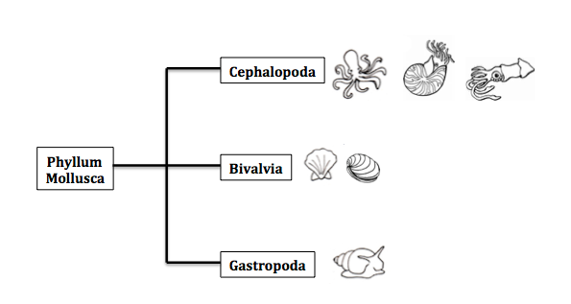
In this activity, you are going to look at shells from marine snails and marine bivalves, learn about the animals that made and lived in these shells, and identify them using a dichotomous key.

Campbell, Neil A., Lawrence G. Mitchell, and Jane B. Reece. Biology: Concepts & Connections. Redwood City: Benjamin/Cummings, 1994. Print.
http://www.gbri.org.au/SpeciesList/Placidadendritica|AlisonCarlisle.aspx?aid=116&PageContentID=3947
http://printablecolouringpages.co.uk

Your Mollusk
Walk around the classroom and observe the different shells that you teacher has set out. Choose one that seems interesting to you, and read the Ecology Card that corresponds to your organism.

Using your knowledge of mollusks and the ‘Ecology Card,’ answer all the questions on this page.

Common name of the mollusk:______________________________________________________________
What class does it belong to? Circle one: Bivalve or Gastropod
2 quantitative (countable/measurable) observations about your shell:
1. _____________________________________________________________________________________________
2. _____________________________________________________________________________________________
2 qualitative (descriptive) observations about your shell:
1. _____________________________________________________________________________________________
2. _____________________________________________________________________________________________
The 2 most interesting facts you learned about your mollusk:
1. _____________________________________________________________________________________________
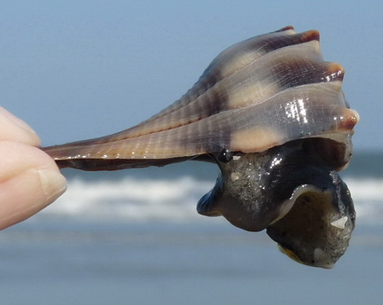
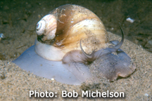
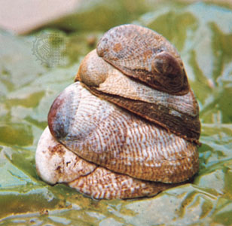
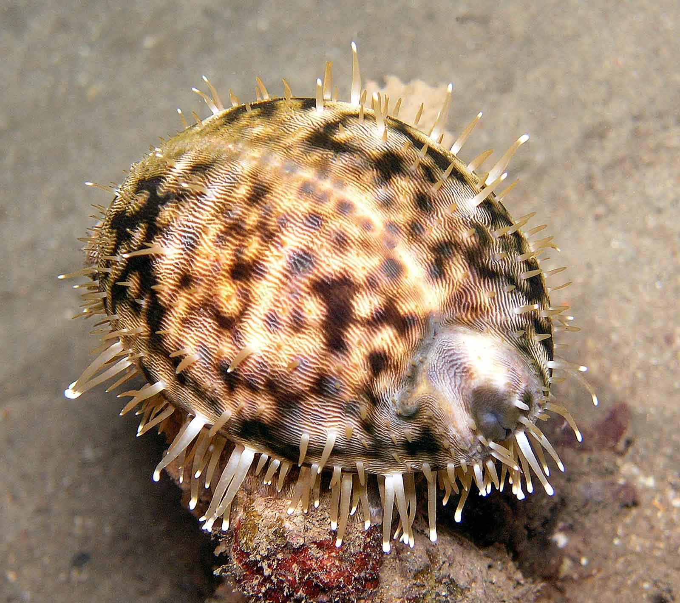
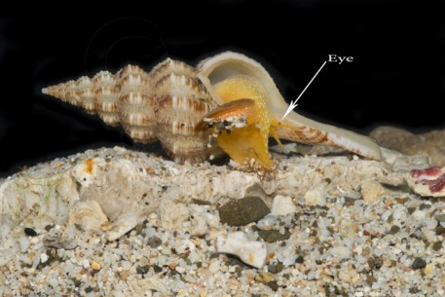
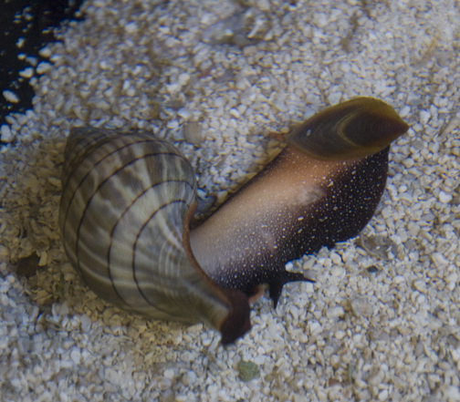
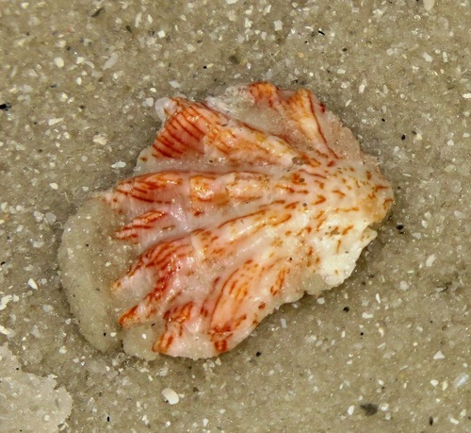
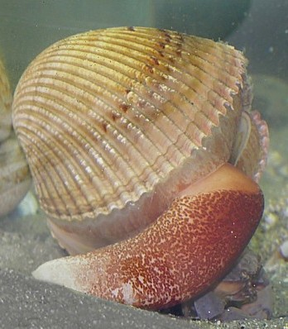
2. _____________________________________________________________________________________________

Marine Mollusk Cards Scavenger Hunt

- A mollusk that is a bivalve:__________________________________________________________
- Mollusk that lives on top of each other:____________________________________________
- A mollusk that is part of a food chain:______________________________________________
- A mollusk that eats other mollusks:________________________________________________
- A mollusk that has some defense mechanism against predators:________________
- A mollusk that feeds by filtering water:____________________________________________
- A mollusk that humans eat:_________________________________________________________
- A snail that is a cannibal (eats its own kind):______________________________________
- A mollusk that humans use for something other than food:______________________
- A mollusk that has a radula (rough tongue): ______________________________________

Mollusks Dichotomous Key Results

Using the Marine Mollusks: A Dichotomous Key (8 specimens or 12 specimens) handouts, write the common name of the shells that you identified.

Shell 1. _____________________________________________
Shell 2. _____________________________________________
Shell 3. _____________________________________________
Shell 4. _____________________________________________
Shell 5. _____________________________________________
Shell 6. _____________________________________________
Shell 7. _____________________________________________
Shell 8. _____________________________________________

Shell 9. _____________________________________________
Shell 10. _____________________________________________
Shell 11. _____________________________________________
Shell 12. _____________________________________________

Making your Own Marine Mollusk Dichotomous Key

This is the final project of the dichotomous key lab. Working with a partner or with your small lab group:

#1. Choose 4 shells from the ones you have already identified (numbers 1-8 or 1-12) and set them on your tray along with the corresponding cards.
#2. Choose 4 shells that were not identified and set them on your tray along with the corresponding cards.
#3. Using the existing key, the cards and your knowledge of mollusks, create a new dichotomous key to identify the 8 shells on your tray.

1a. ____________________________________________________________________________________________________
1b. ____________________________________________________________________________________________________

2a. ____________________________________________________________________________________________________
2b. ____________________________________________________________________________________________________

3a. ____________________________________________________________________________________________________
3b. ____________________________________________________________________________________________________

4a. ____________________________________________________________________________________________________
4b. ____________________________________________________________________________________________________

5a. ____________________________________________________________________________________________________
5b. ____________________________________________________________________________________________________

6a. ____________________________________________________________________________________________________
6b. ____________________________________________________________________________________________________

7a. ____________________________________________________________________________________________________
7b. ____________________________________________________________________________________________________

8a. ____________________________________________________________________________________________________
8b. ____________________________________________________________________________________________________

9a. ____________________________________________________________________________________________________
9b. ____________________________________________________________________________________________________

