
CIBT – Cornell Institute for Biology Teachers

The Case of the Missing Diamond Maker

Packing List per station
(highlighted in red is what teachers need to provide)

A. For the Teacher’s fingerprinting demo, the day before the lab
- Orange powder and brush
- Blue light
- Black powder and 4 black powder brushes
- Fingerprinting tape
- A few adult latex gloves inside bag
- Forensics yellow tape
- Forensic evidence numbers

B. For the students making/lifting their own fingerprints, the day before the lab:
1. 12 Fingerprinting pads
2. 12 laminated fingerprinting types handout
3. 12 magnification glasses
4. Glassware

FOR THE DIFFERENT STATIONS THE DAY OF THE LAB

STATION #1. Fingerprinting
- 4 laminated copies of the suspects fingerprint handout
- 4 laminated copies of the evidence fingerprint handout
- 4 magnifying glasses

STATION #2. Chromatography
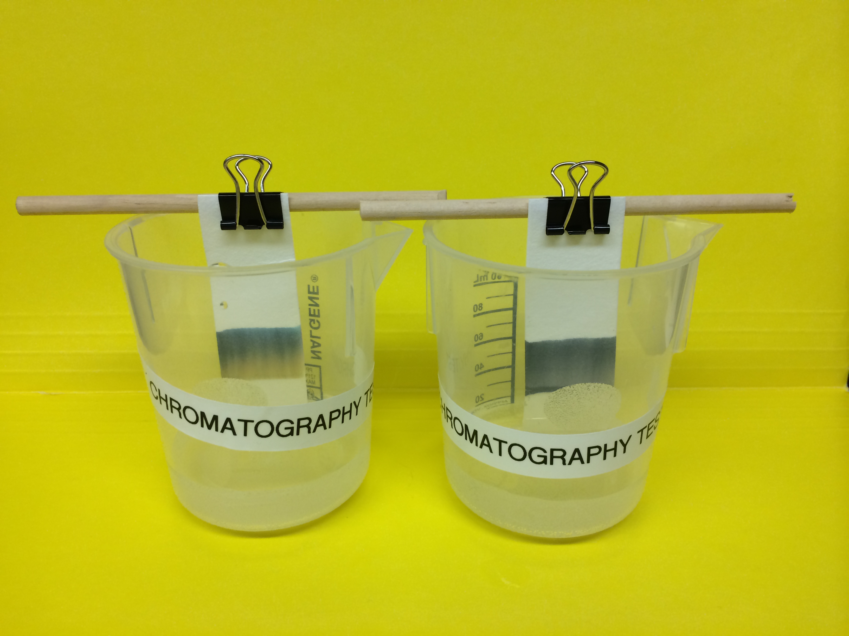
1. Filter paper cut into 2.5X7.5 cm strips
2. 4 plastic beakers labeled ‘Chromatography’
plus one ‘demo’ beaker
3. 4 wooden dowels + 2 extra
4. 4 binder clips + 2 extra
5. 4 different black markers labeled A,B,C,D
6. Prepared evidence strip prepared with ‘C’ black
pen, labeled ‘Evidence’
7. Trays, one per group labeled with the group’s number
8. Rulers to measure the 2 cm in the filter paper
9. Trash beaker
10. Scotch tape (to tape the chromatography samples to the handouts)
11. Stopwatches?
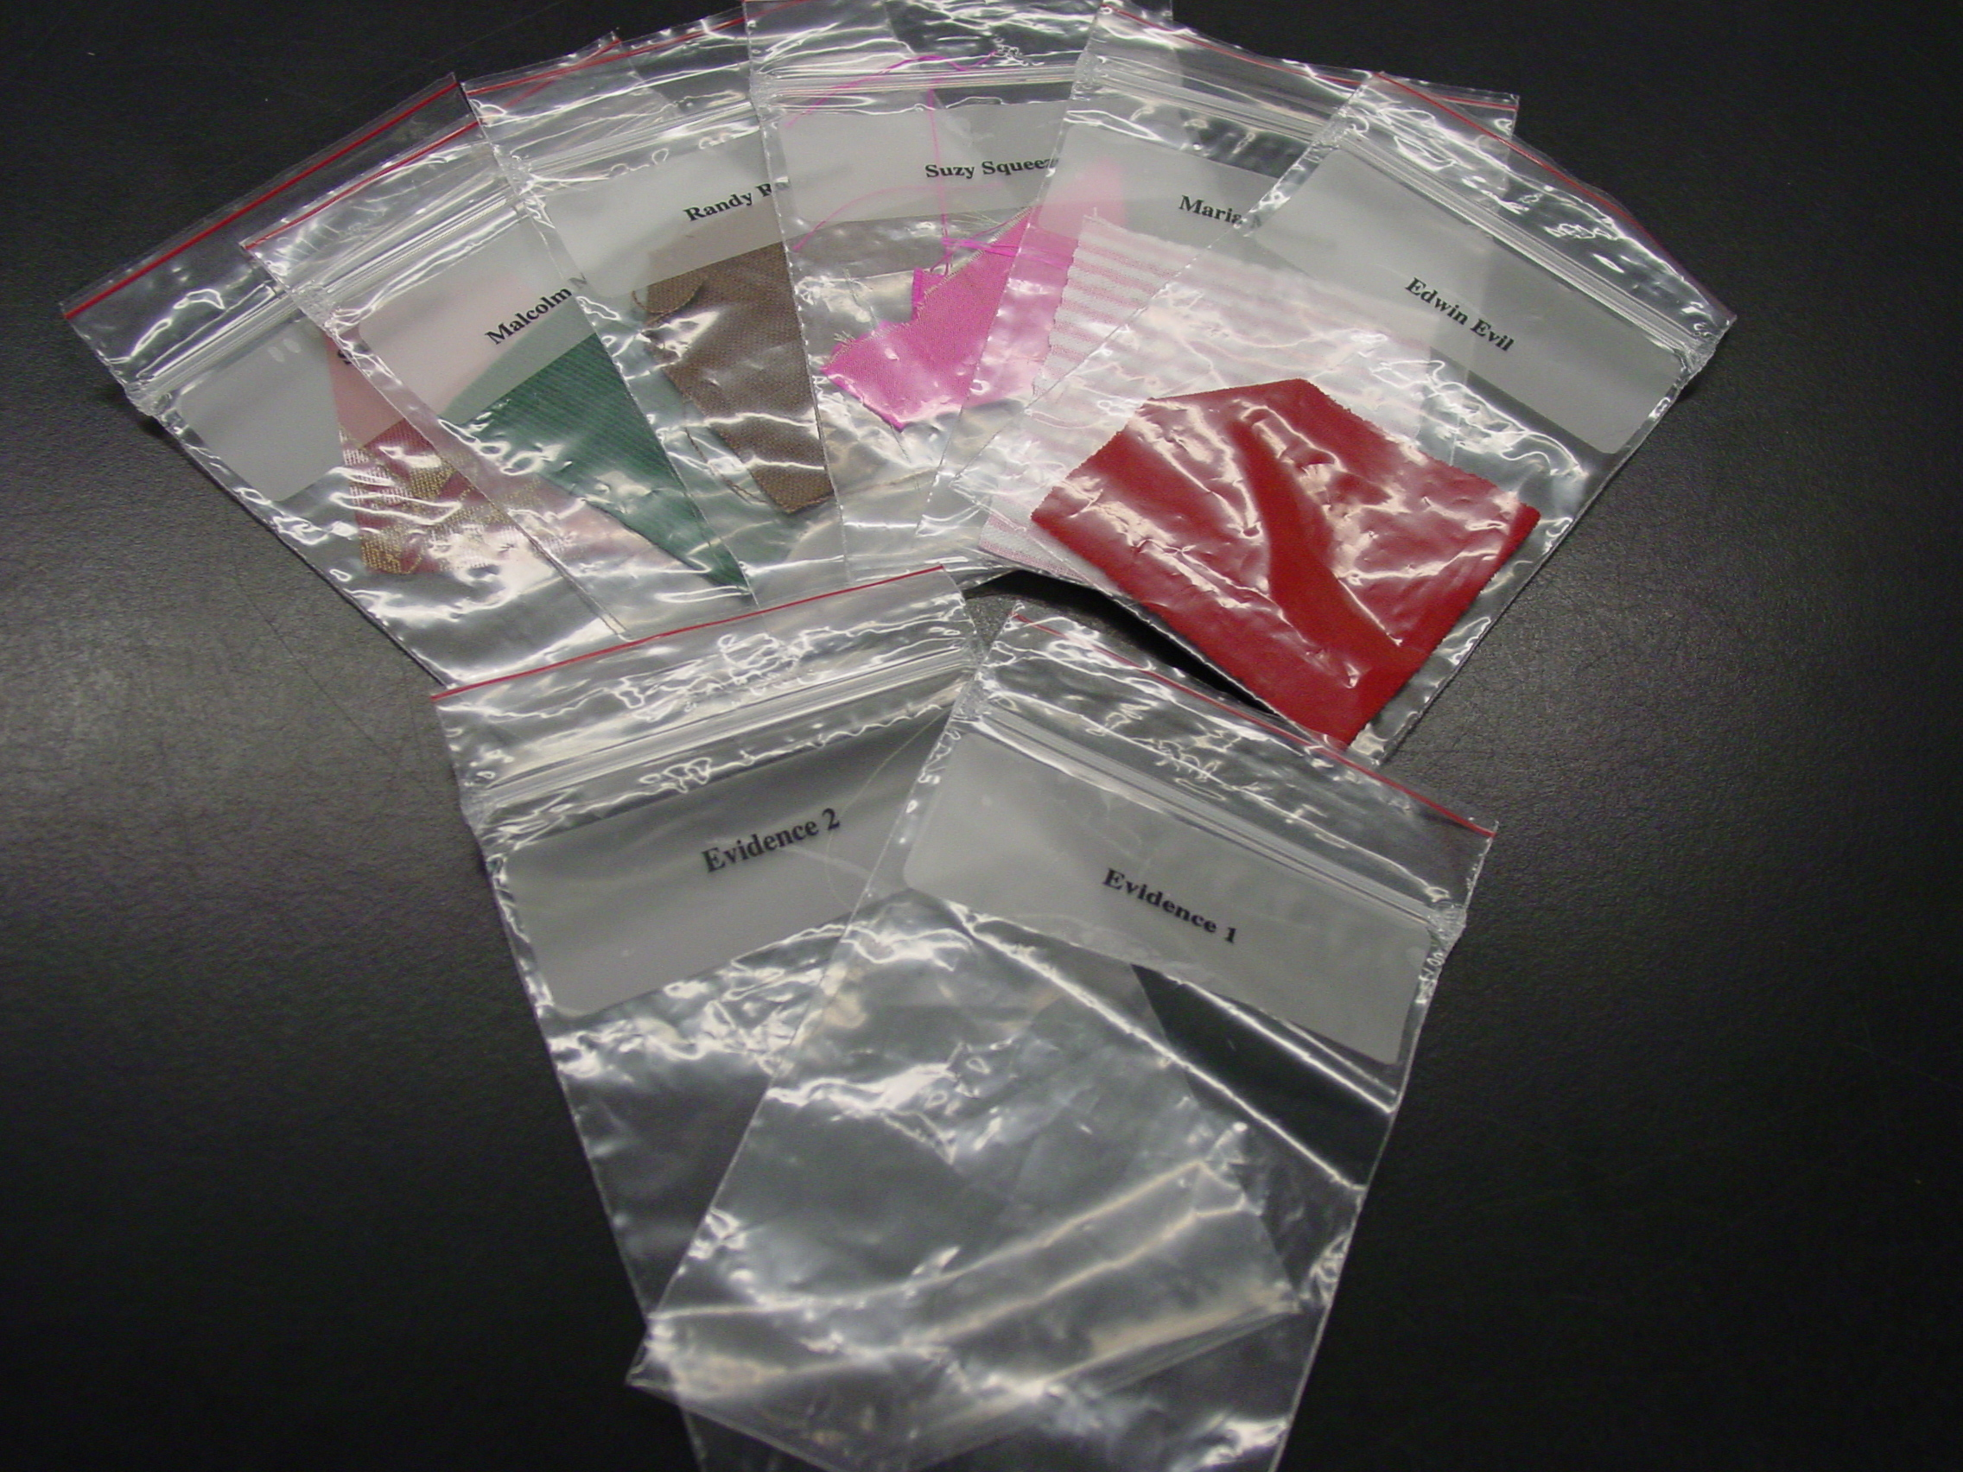
STATION #3. Fiber Analysis
- 6 different fabrics cut into 5 cm squares, inside different baggies
and labeled: Maria, Randy, Sandra, Malcom, Dr. Evil and Dr. Squeeze.
- Four magnifying glasses

STATION #4. Smells
- 5 plastic canisters labeled: Sandra, Dr. Evil, Randy, Malcom,
Evidence
- Strips of filter paper sprayed with 4
different perfumes.
(The filter paper in the ‘evidence’ canister was sprayed with Sandra’s perfume)

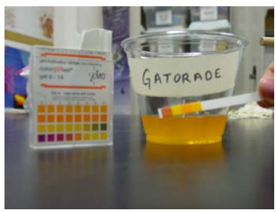
STATION #5. Spilled liquid
- Set up 4 plastic cups or beakers labeled ‘orange juice’, ‘water’, ‘Alka seltzer’ and ‘Gatorade’. Pour orange juice, water, Alka Seltzer and Gatorade in the corresponding cup.
2. Provide pH paper and paper towels
(The pH of evidence is 3)
4. Trash beaker

STATION #6. Spilled powder
- Laminates with the instructions and places for ‘baking powder’
‘baking soda’ and ‘powdered sugar’
- 3 containers labeled and full of the following: baking powder, baking soda, powdered sugar
3. 1 water dropper
4. 1 vinegar dropper
5. 3 scoops labeled ‘baking powder’ ‘baking soda’ and ‘powdered
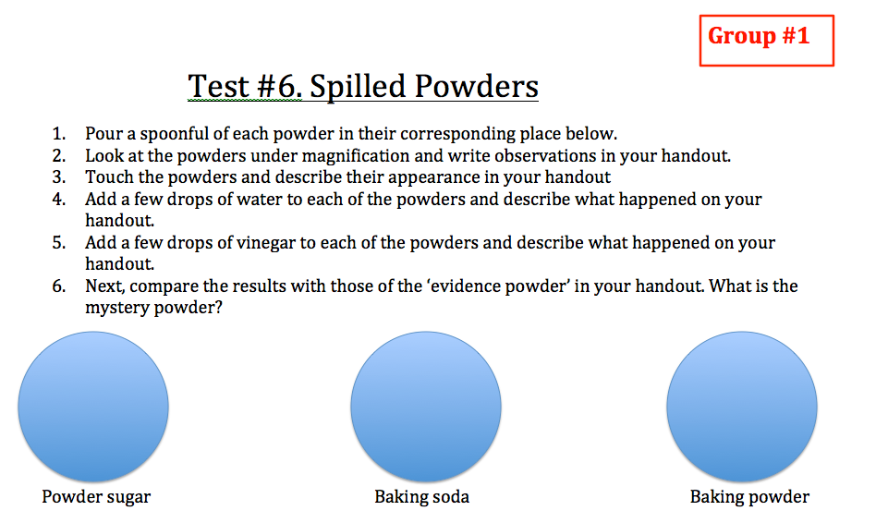
sugar’
6. Paper towels
7. Trash beaker

